

Ann's Run 4.6
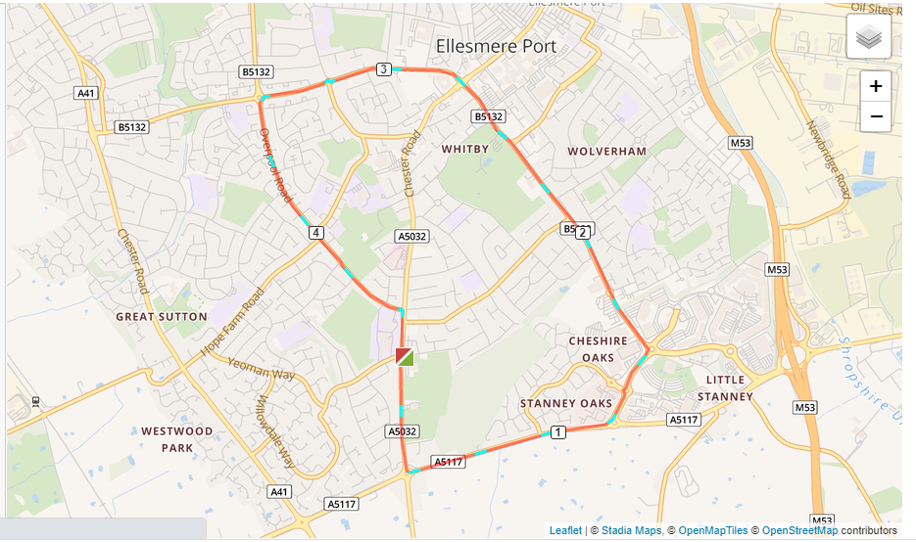

- Left out of the club and left on to Chester Road.
- Run to the Strawberry roundabout and turn left down the A5117.
- Turn left at the Audi garage roundabout and past M&S.
- Turn left at the Outlet Village roundabout and past David Lloyd gym all the way to the Police Station.
- Go straight over the traffic lights at the Police Station up Sutton Way
- When you get to Sutton Way roundabout turn left onto Overpool Road and follow that all the way to Whitby School and back to the club.

