Cambridge Road 5.2 Miles
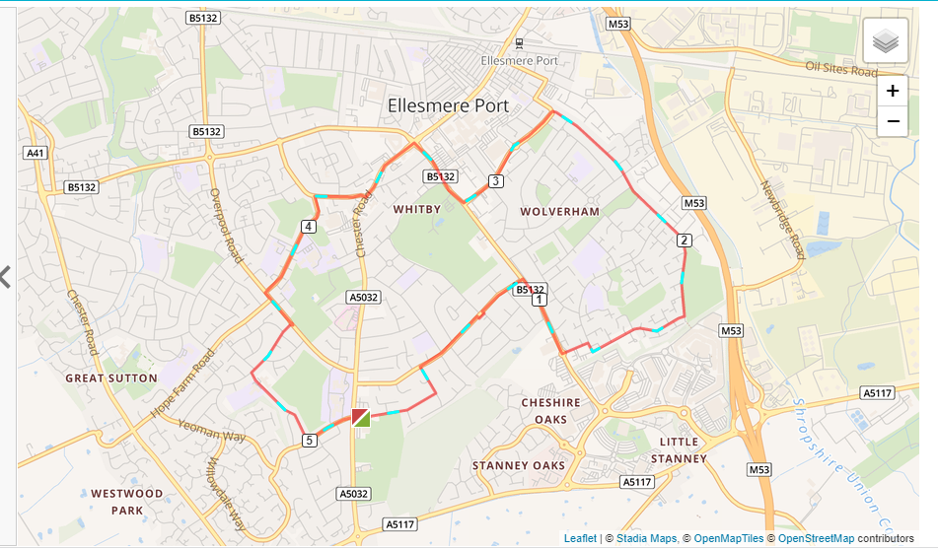

- Out of the club down Woodsome Drive and left onto Woodland Road.
- Right on Underwood Drive then run bottom.
- Turn right towards the new leisure centre and turn left onto Dover Drive.
- At the end of Dover Drive turn right onto Alnwick Drive and follow that to the bottom where it joins Thornton Road past the old Stadium.
- This joins Cambridge Road which you follow until a right turn on McGarva Way and follow that all the way up to the old EPIC.
- Turn right and run to the Police Station.
- Turn left at the Police Station then right into Pooltown Road.
- Left into Capenhurst lane past Catholic High School.
- Turn left onto Overpool then right onto Broadland Road.
- Left into Eddisbury past the School to the end.
- Left onto Sycamore Drive and back to the club.

