Cheshire Oaks 7.5 miles
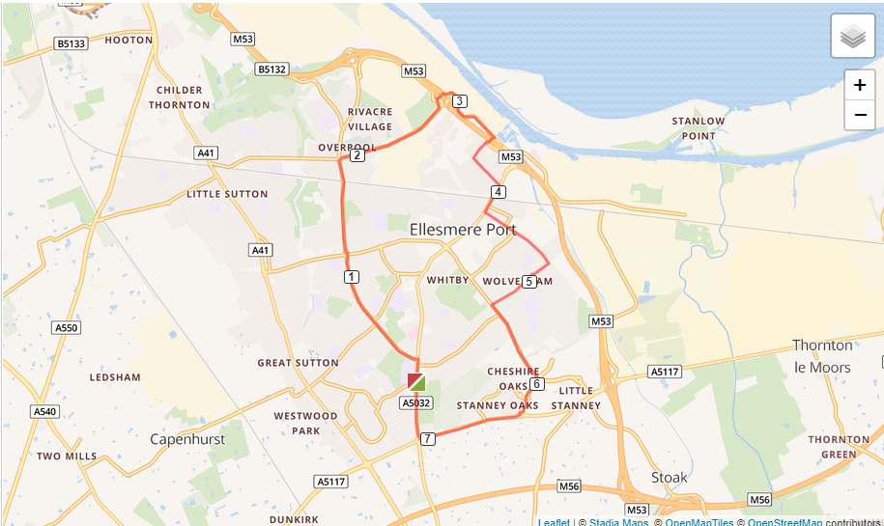

- Turn right out of the club onto Chester Road.
- Follow Chester Road to Overpool Road and turn left.
- Run all the way down to Cemetery Gates roundabout and turn right
- Run up to the motorway roundabout and go straight over the roundabout, on to Merseyton Road
- Turn right at the next roundabout, on to Grace Road
- Turn left at the next roundabout onto Westminster Road.
- Run to the end of Westminster Road and turn right and run over Westminster Bridge.
- Turn left at Cambridge Road and run until Wolverham Road.
- Turn right at Wolverham Road and run all the way up the road to Stanney Lane.
- Turn left at Stanney Lane and run to M&S, turn right at M&S and run past M&S, past Porsche garage, turn right after the Porsche garage.
- Run past Stanney Woods, turn right on Chester Road and run back to the club

