Hillside Drive 5.1 miles
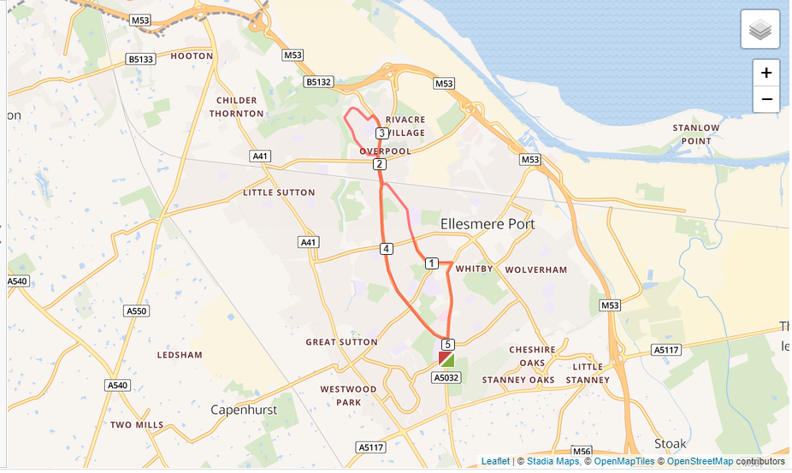

- Turn right out of the club onto Chester Road.
- Follow Chester Road all the way past Morrisons.
- Turn left onto Pooltown Road and follow that straight over the roundabout on Sutton Way.
- Keep following Pooltown Road over Princes Road and join Overpool Road.
- Run to Cemetery Gates roundabout and go straight over.
- Turn left onto Hillside Drive and follow that doing a loop until you turn left onto Rivacre Brow then right onto Rivacre Road.
- Head back to Cemetery Gates roundabout.
- Go straight over the roundabout and along Overpool Road.
- Straight over Sutton Way roundabout up to Whitby School and back to the club.

