North Road 8 Miles
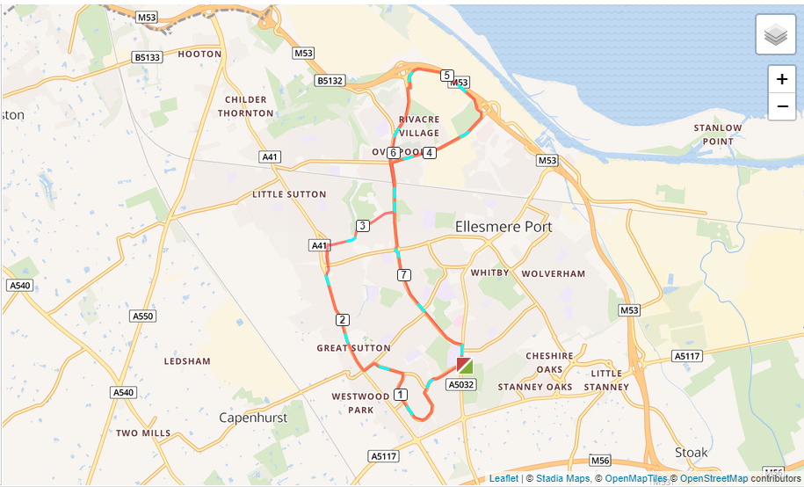

- Out of the club straight over onto Sycamore Drive.
- Follow Sycamore Drive all the way past the mound round the loop which joins onto Willowdale. Follow Willowdale to Yeoman Way.
- Turn left onto Yeoman Way and follow it to Hope Farm Road.
- Turn left towards the Wirral Hundred traffic lights.
- At the lights turn right and run down the A41 to Great Sutton Church.
- Cut through past the Church. Cross over Sutton Way to the Swan Pub.
- Turn right down Mill Lane all the way to the bottom and back up the hill to Mill Lane School.
- At Overpool Road turn left to Cemetery Gates roundabout.
- At the roundabout turn right onto Rossmore Road East past Lookers to the roundabout.
- At the roundabout turn left onto North Road (it runs alongside the M53).
- At the end turn left towards Rivacre back to Cemetery Gates roundabout.
- Straight over the roundabout onto Overpool Road and follow that over Sutton Way roundabout up to Whitby School and back to the club.

