Regent Street 5 Miles
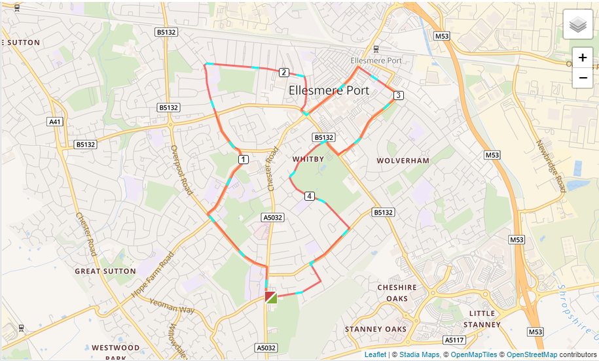

- Left of the club and right on Chester Road
- Left down Overpool Road.
- Turn right onto Capenhurst Lane past Catholic High School.
- Left onto Pooltown Road and straight over Sutton Way.
- Turn right onto Regent Street past the College to the bottom.
- Turn right onto Flat Lane then left towards the traffic lights.
- At the traffic lights turn left onto Whitby Road and go through the town centre.
- Turn right onto Cambridge Road and follow that until you turn right onto McGarva Way all the way to the end.
- Turn right but then immediate left up Thamesdale.
- Turn left onto Park Drive and follow that until it joins Underwood Drive.
- Turn right onto Underwood Drive, left into Woodland Road and right into Woodsome Drive and back to the club.

