Stanney Grange 8 Miles
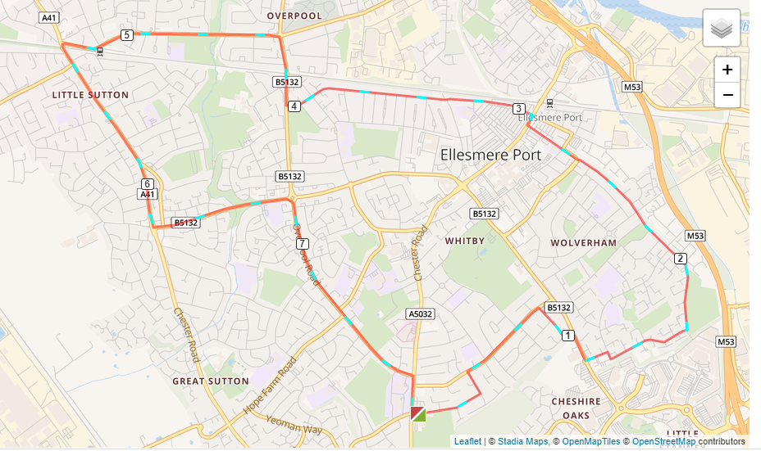

- Out of the club down Woodsome Drive and left onto Woodland Road.
- Right on Underwood Drive then run bottom.
- Turn right towards the new leisure centre and turn left onto Dover Drive.
- At the end of Dover Drive turn right onto Alnwick Drive and follow that to the bottom where it joins Thornton Road past the old Stadium.
- This joins Cambridge Road which you follow to the end.
- Turn right onto Whitby Road then first left onto Princes Road.
- Run to the top of Princes Road and turn right onto Overpool Road to Cemetery Gates roundabout.
- Turn left at the roundabout onto Rossmore Road West and follow that to the end to Hollywood Car Sales.
- Turn left onto the A41/Chester Road through little Sutton all the way to Green lane traffic lights.
- Turn left onto Sutton Way and down to Sutton Way roundabout.
- Turn right onto Overpool to Whitby School and back to the club.

