Sutton Way 3.6 Miles
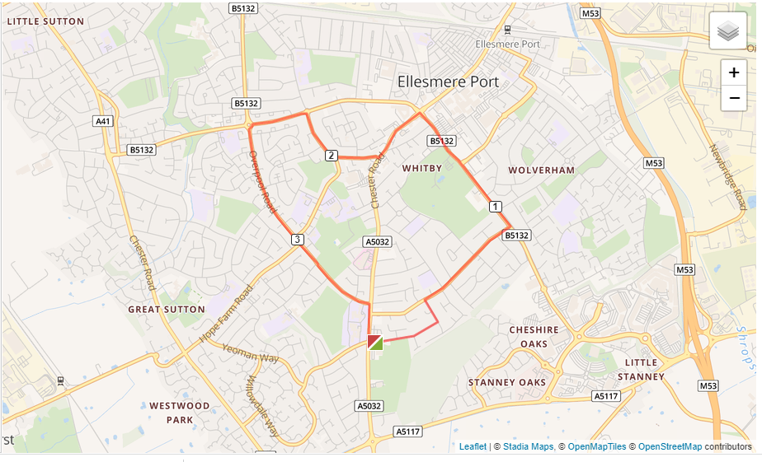
- Out of the club onto Woodsome Drive then left onto Woodland Road.
- Turn right onto Underwood Drive and follow that to the bottom.
- Turn left and follow that past Whitby Park down to the Police Station.
- Turn left at the Police Station onto Chester Road. Run towards Whitby village but turn right onto Pooltown Road and follow that to Sutton Way.
- Turn left then run to Sutton Way roundabout.
- Turn left at the Sutton Way roundabout and run up Overpool Road
- At the end of Overpool Road turn right and run past Whitby High School and back to the club

