Underwood Drive 6.3 miles
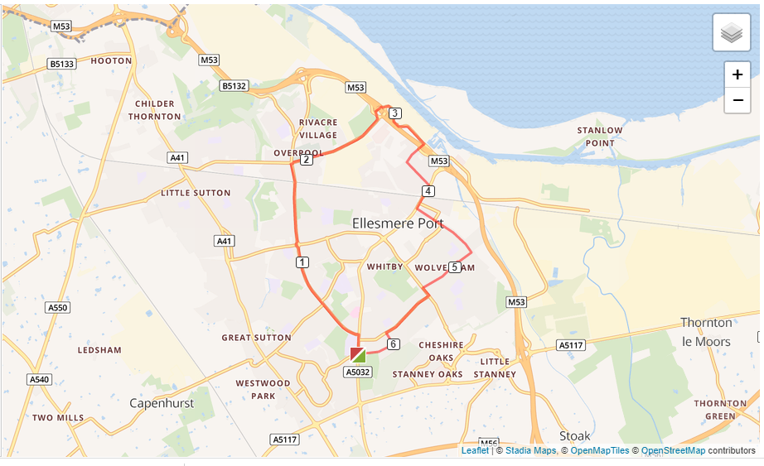

- Left out of the club and turn right onto Chester Road.
- Follow Chester Road to Overpool Road and turn left.
- Run all the way down to Cemetery Gates roundabout and turn right
- Run up to the motorway roundabout and go straight over the roundabout, on to Merseyton Road
- Turn right at the next roundabout, on to Grace Road
- Turn left at the next roundabout onto Westminster Road.
- Run to the end of Westminster Road and turn right and run over Westminster Bridge.
- Turn left at Cambridge Road and run until Wolverham Road.
- Turn right at Wolverham Road and run all the way up the road to Stanney Lane.
- Turn left at Stanney Lane and then turn right onto Underwood Drive
- Turn left on to Woodland Road and then right on to Woodsome Drive and run back to the club

