
Backford Loop 4.3 mile

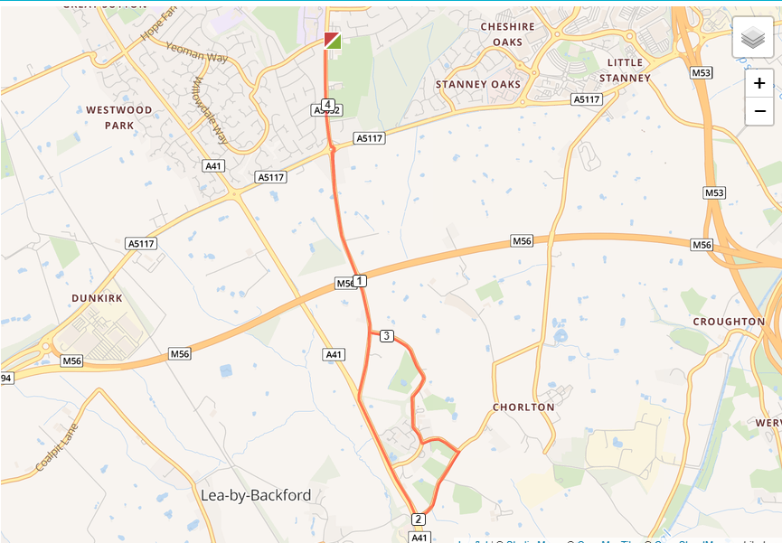

- Out of the club and turn left, turning left again on Chester Road
- Cross the Strawberry roundabout and run down to traffic lights
- Turn left at traffic lights
- Turn left to Rake Lane and turn left again at The Channel
- At the top of The Channel turn right onto Gordon Lane
- At the end of Gordon Lane turn right to Whitby Lane
- Cross the Strawberry roundabout and run back to the club

