
Canal shorter 4.8 mile

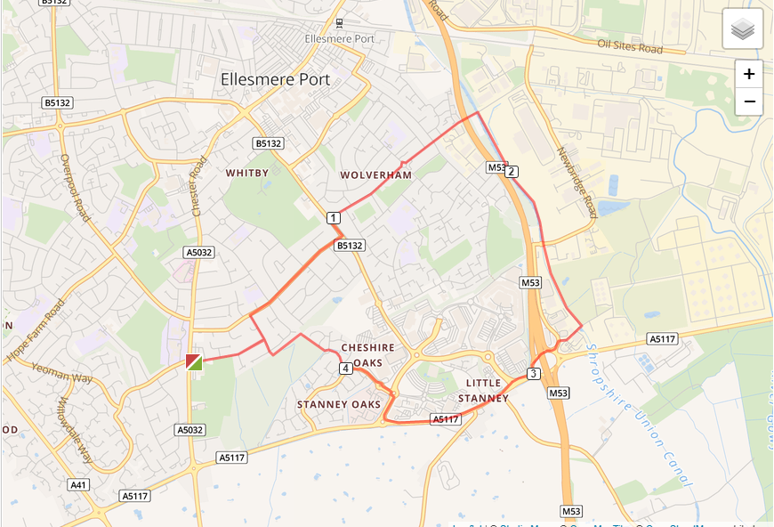

- Out of the club and turn right, turning left on Woodland Road
- Turn right on Underwood Drive and run the length of the road
- Turn left on Chester Road and turn right onto Wolverham Road
- At end of Wolverham Road cross to Lees Lane and run over the canal
- Turn left and take the canal tow path, turning left again
- Leave the canal at Harley Davidson garage onto A5117, run down A5117
- Turn right at Audi garage onto Longlooms Road and left at M&S into Stanney Woods Avenue
- Turn right into Guernsey Drive and follow it until you enter the Stanney Woods
- Turn right and run around the woods until you exit the Woods on Woodland Road by the manhole cover
- Turn left into Woodsome Drive and run back to the club

