
Chester Zoo 7.4 mile

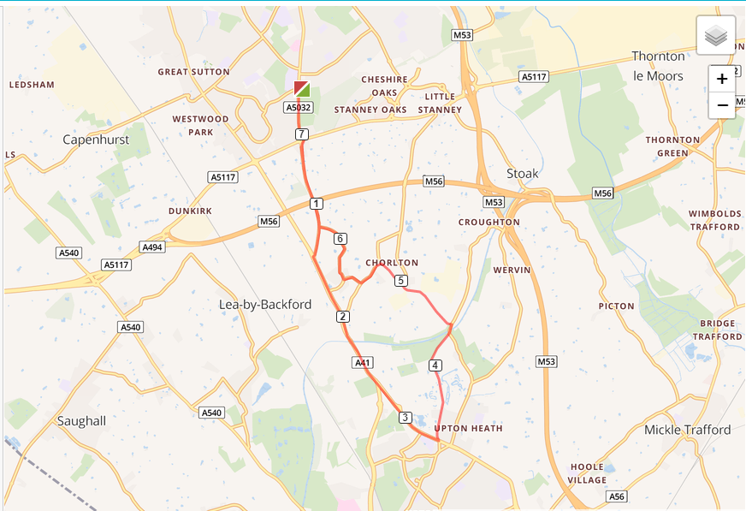

- Out of the club and turn left, turning left again on Chester Road
- Cross Strawberry roundabout and run down Whitby Lane to the end
- At traffic lights turn left and run up Backford hill and cross the Chester zoo roundabout
- Turn left into Flag Lane North and run through the zoo to the end of the path
- Turn left onto Caughall Road and left again into Chorlton Lane
- At end of road turn left onto Rake Lane, then next right onto The Channel
- Turn right onto Gordon Lane and run the length of the road
- Turn right onto Whitby Lane, cross Strawberry roundabout and back to the club

