
Croughton / Seven Sisters 7 mile

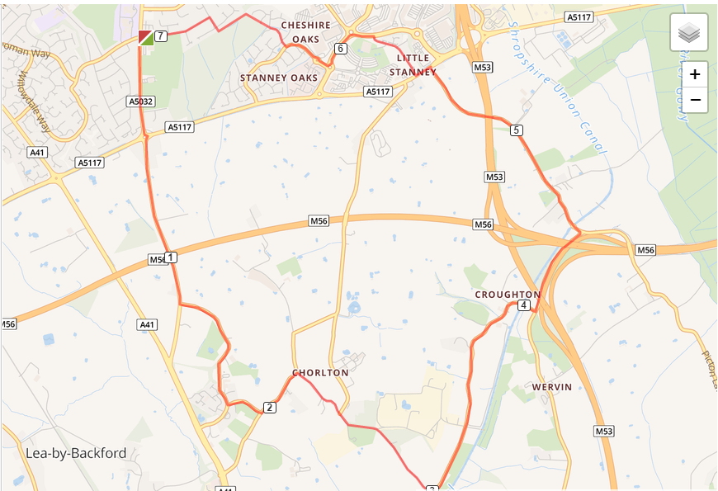

- Out of the club and turn left, turning left again on Chester Road
- Cross the Backford roundabout and carry on until you reach Gordon Lane
- Turn left into Gordon Lane and run until you reach The Channel
- Turn left and run the length of The Channel turning left on Rake Lane
- Turn right into Chorlton Lane and run the length of the road
- Turn left Croughton College Road and run the length of the road
- Turn left onto Picton Lane and left again onto Little Stanney Lane
- Run the length of Little Stanney Lane, turning left at the end onto A5117
- Turn right into Stanney Lane and run the length of the road until you reach Coliseum Way turning left at the end
- Turn left onto Longlooms Road and right at M&S into Stanney Woods Avenue
- Turn right into Guernsey Drive and follow it until you enter the Stanney Woods
- Turn right and run around the woods until you exit the Woods on Woodland Road by the manhole cover
- Turn left into Woodsome Drive and run back to the club

