
Demage Lane 5.3 mile

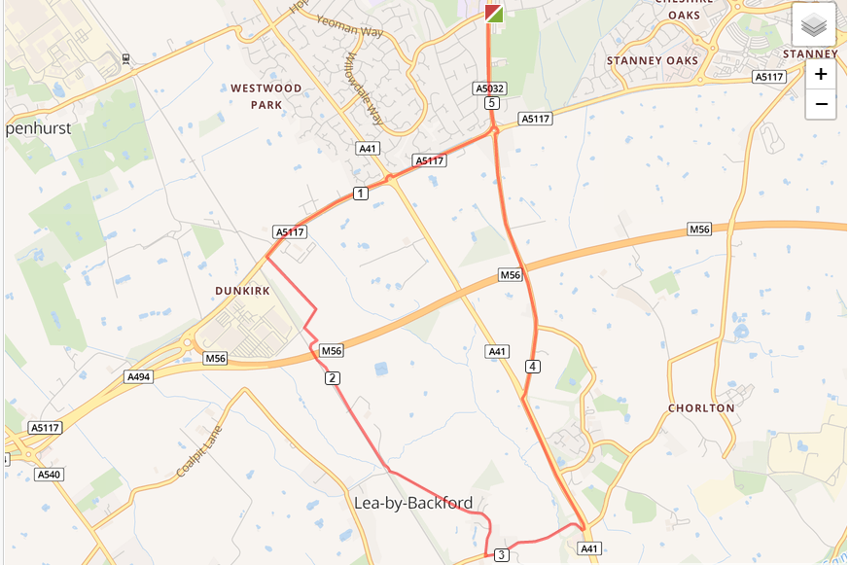

- Out of the club and turn left, turning left again on Chester Road
- Turn right at Strawberry roundabout and run down to Bridle Lane
- Turn right and run the length of Bridle Lane going through a number of gates
- Turn left at end on Bridle Lane on to Demage Lane and run the length of the road
- Turn left onto Station Road and run up Mollington Hill to the end of the road
- Turn left on A41 and run to traffic lights
- Turn right at traffic lights and run to Strawberry roundabout
- Cross the roundabout and run back to the club

