
Ledsham 7.6 miles
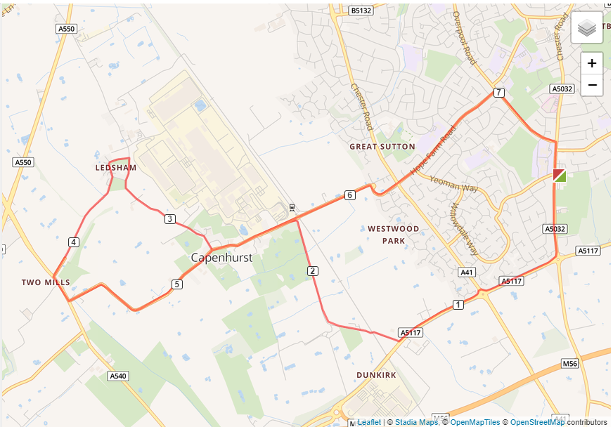
- Turn left out of the club and left again on Chester Road
- At Strawberry roundabout turn right and run to Backford roundabout, going straight on.
- At Dunkirk Lane turn right and run the length of the road.
- Turn right onto Capenhurst Lane and run through the village to Rectory Lane.
- Turn right and run until you reach Ledsham Village.
- Turn left into Ledsham Village and follow the road up to A540 by Two Mills church.
- Turn left at the church and run along the path until Capenhurst Lane.
- Turn left into Capenhurst Lane and run the length on the road until A41
- Cross the A41 and run the length of Hope Farm Road
- Turn right onto Overpool Road and right again at the end of the road and back to the club

