
Pretty Bridge 6.1 mile

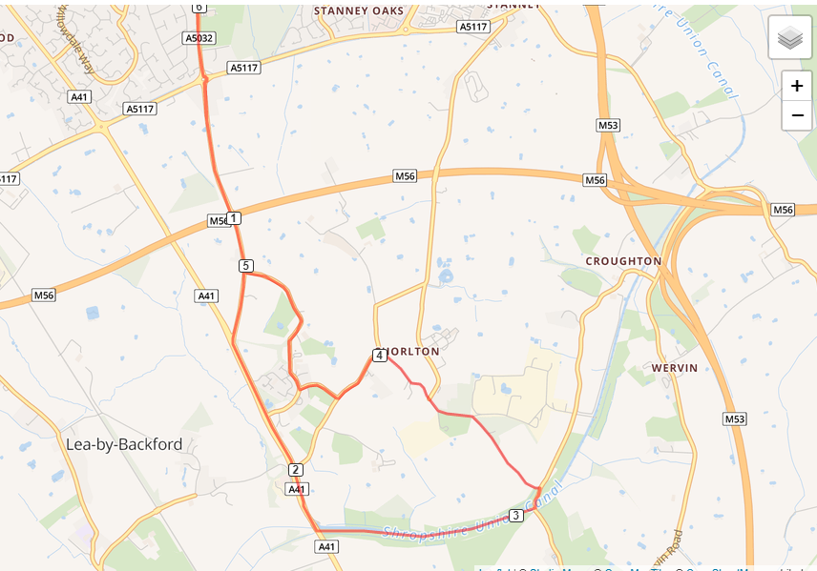

- Out of the club and turn left, turning left again on Chester Road
- Cross Strawberry roundabout and run down Whitby Lane to the end
- At traffic lights turn left and drop on the canal at the bottom of Backford hill
- Leave the canal at Pretty Bridge, turning left on Caughall Road
- Turn left into Chorlton Lane, run the length of the road
- At Rake Lane turn left, then the next right into The Channel
- Turn right on to Gordon Lane and run the length of the road
- At Whitby Road turn right, cross over Backford roundabout and run back to the club

