
Townfield Lane 8.2 mile

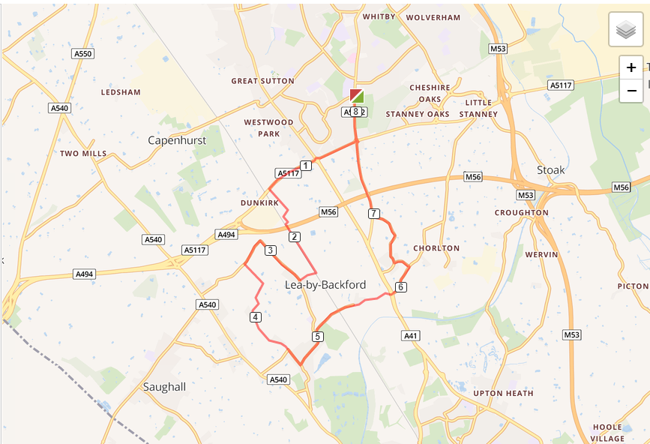

- Out of the club and turn left, turning left again on Chester Road
- Turn right at Strawberry roundabout and run down to Bridle Lane
- Turn right and run the length of Bridle Lane going through a number of gates
- Turn right at end on Bridle Lane on to Demage Lane and run the length of the road
- Turn right onto Grove Road which joins Coalpit Lane
- Turn right into Townfield Lane and run down until you reach Well Lane
- Turn left and run the length of the road which turns into Station Road
- Run up Mollington hill to the end of the road
- Cross the road to Rake Lane and turn left at The Channel
- At the top of The Channel turn right onto Gordon Lane
- At the end of Gordon Lane turn right to Whitby Lane
- Cross the Strawberry roundabout and run back to the club

