
Canal Long 8.3 mile

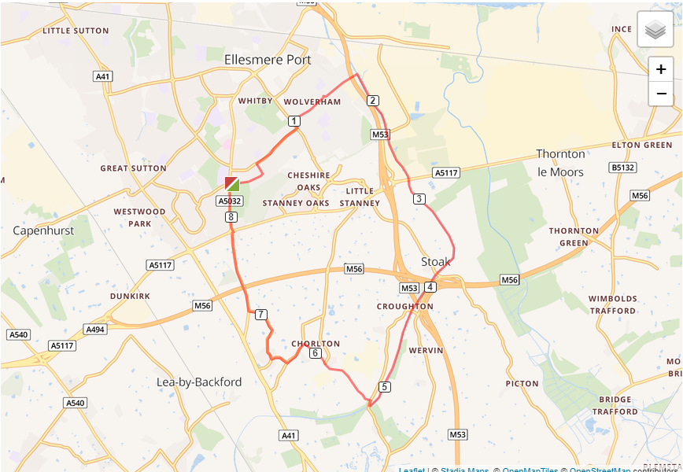

- Out of the club and turn right, turning left on Woodland Road
- Turn right on Underwood Drive and run the length of the road
- Turn left on Chester Road and turn right onto Wolverham Road
- At end of Wolverham Road cross to Lees Lane and run over the canal
- Turn left and take the canal tow path, turning left again
- Leave the canal at Pretty bridge turning left then immediate right to cross the canal
- Turn left into Chorlton Lane, run the length of the road
- At Rake Lane turn left, then the next right into The Channel
- Turn right on to Gordon Lane and run the length of the road
- At Whitby Lane turn right, cross over Backford roundabout and run back to the club

