
Park Drive 4.1 miles
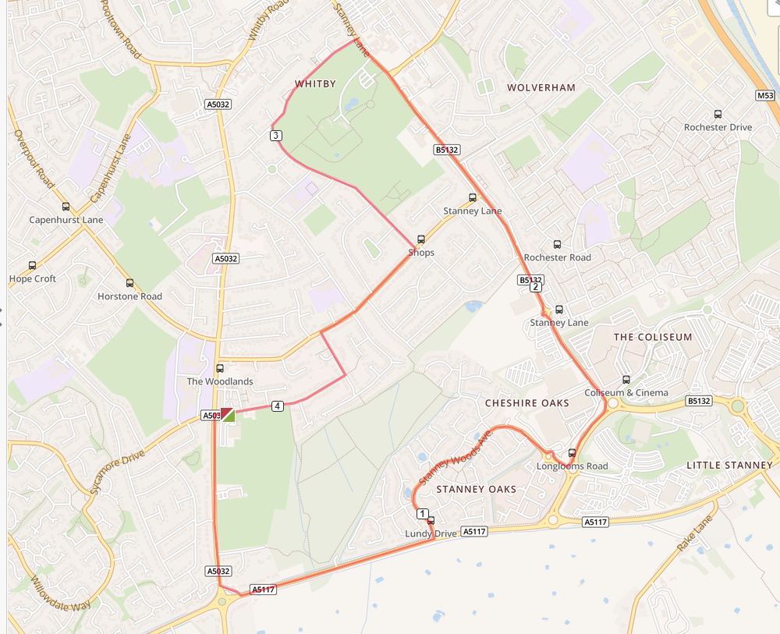

- Turn left out of the club and left again on Chester Road.
- At Strawberry roundabout turn left and run to Stanney Oaks traffic lights.
- Turn left at the lights and run the length of Stanney Woods Avenue.
- Go straight on at the first roundabout and turn left at the second roundabout towards the Cheshire Oaks.
- Turns left at the Cheshire Oaks and run down to Thamesdale, turning left.
- Turn left on to Park Drive and run the length of the road.
- Turn right onto Underwood Drive and run to Woodland Road
- Turn left onto Woodland Road and then right on Woodsome Drive and run back to the club

