Stanney Woods 4 miles

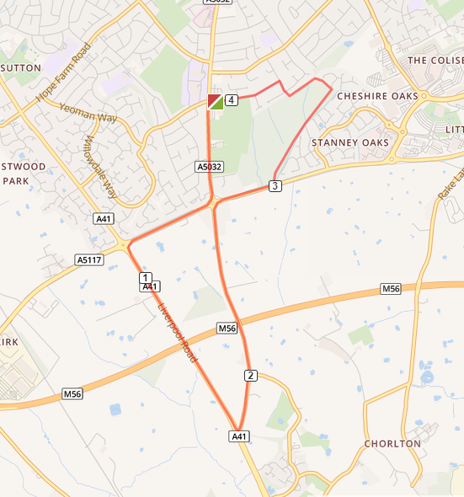

- Head left out of the club and left on to Chester Road
- At the roundabout turn right on to the A5117
- At the next roundabout turn left and cross the road, on to Liverpool Road
- At the traffic lights turn left on to Whitby Lane
- At the roundabout turn right and head towards Cheshire Oaks
- Enter the woods at the car park and turn right in the woods
- Leave the woods, turning right, just after the manhole cover and on to Woodland Road
- Turn left in to Woodsome Drive and return to the club

