Backford shorter
(3.8 miles)

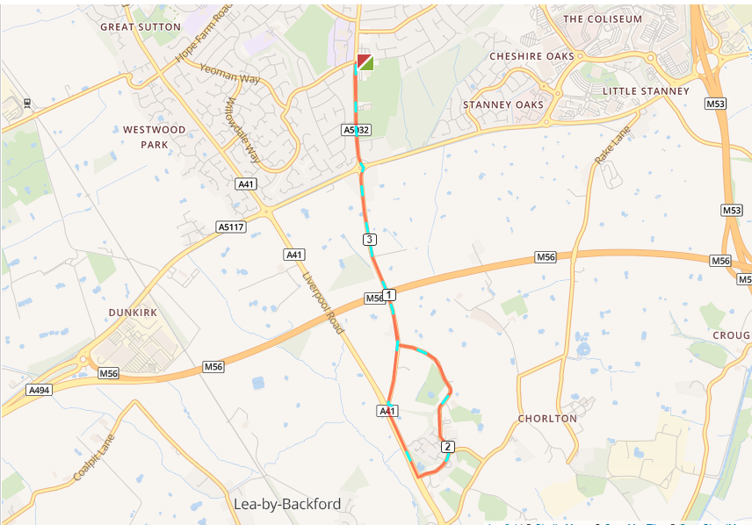

- Turn left out of the club, turning left and left again on to Chester Road
- Run straight on at the Strawberry roundabout
- At the traffic lights turn left towards Chester
- Turn left on to Church Lane which turns into Gordon Lane
- At the end of Gordon Lane turn right onto Whitby Road
- Run over the Strawberry roundabout and run back to the club

