Liverpool Road 3.8 miles

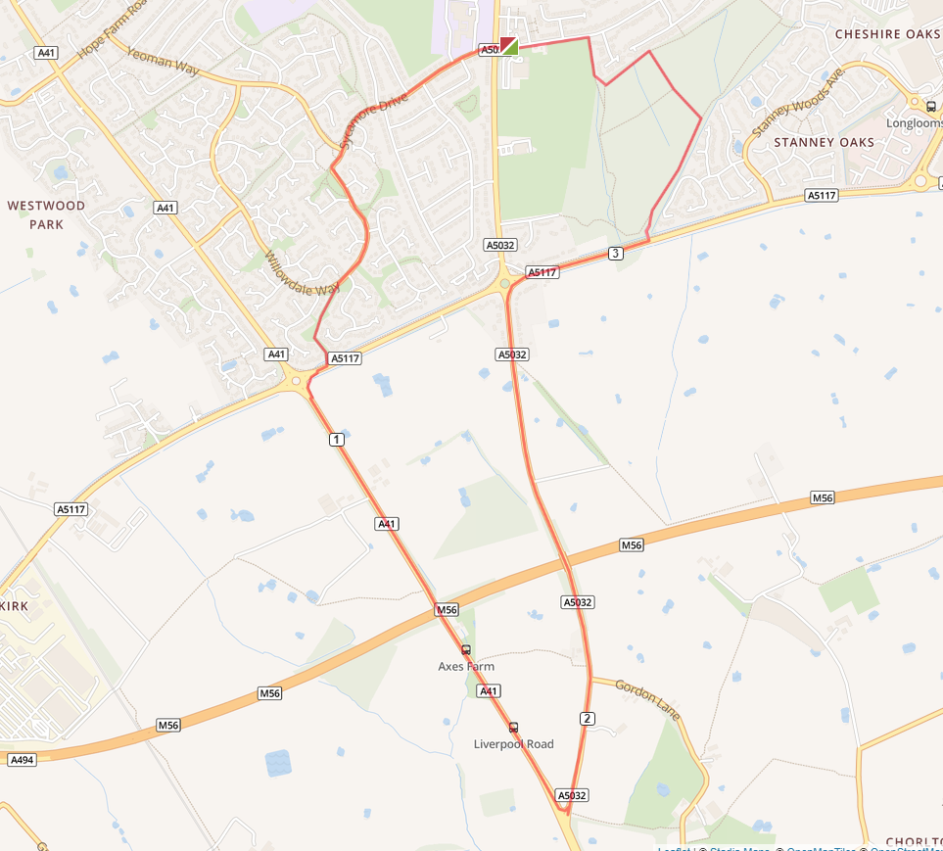

- Turn left out of the club and cross Chester Road on to Sycamore Drive
- Follow Sycamore Drive to Willowdale Way
- At Silverbirch Way take the bridle path to Strawberry Way and turn right at the end of the path
- Turn left at the roundabout and run down Liverpool Road to the traffic lights.
- Turn left at the lights to Whitby Road which runs into Whitby Lane
- Turn right at the Strawberry roundabout and run to the Stanney Woods car park
- Turn right in the woods and run around the woods, leaving the woods, turning right, at the end of the woods by The Whitby Club.
- Run down the path and turn left at the end and run back to the club

