Dunkirk Lane extended
5.6 miles
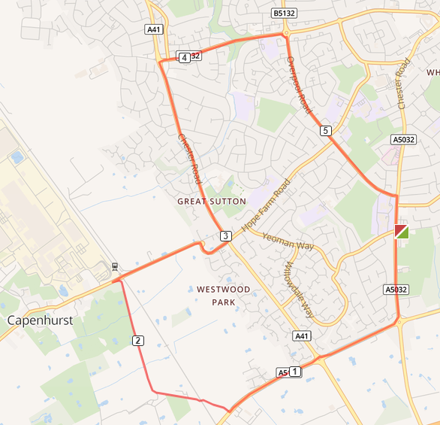

- Out of the club and turn left and left again on to Chester Road
- At Strawberry roundabout turn right on to A5117 and straight on at the Backford round about
- At Dunkirk Lane turn right and run the length of the road
- At the end of the road turn right and over the railway bridge and run the length of the road
- At A41 turn left and run to Sutton Way
- Turn right at Sutton Way and run to the Sutton Way roundabout
- Turn right at the roundabout and run the length of the road
- Turn right at Chester Road and return to the club

