Marquis short 3.6 miles

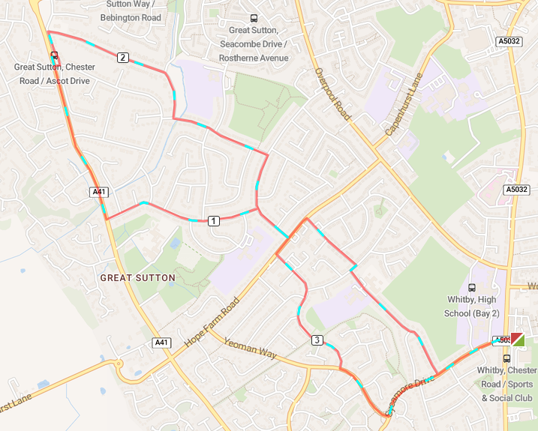
Out of the club and turn left, cross over to Sycamore Drive
Turn right on to Eddisbury road, at the end of the road turn right
Turn left on to Bridge Meadow and run the length of the road
Turn left and then a right turn on to Summertrees Road
Turn left on to Kendal Drive and run the length of the road
Turn right on A41 and run down to St Johns Church (Church Lane)
Run the length of Church Lane and turn left on to Baker Drive
At the end of Baker Drive turn right on to Summertrees Road
At the end of the road turn right, then turn left on Randle Meadow
At the end of Randle Meadow turn left on Yeoman Way
At the end of Yeoman Way turn right to Sycamore Drive and back to the club

