Mill Lane 4.8 miles
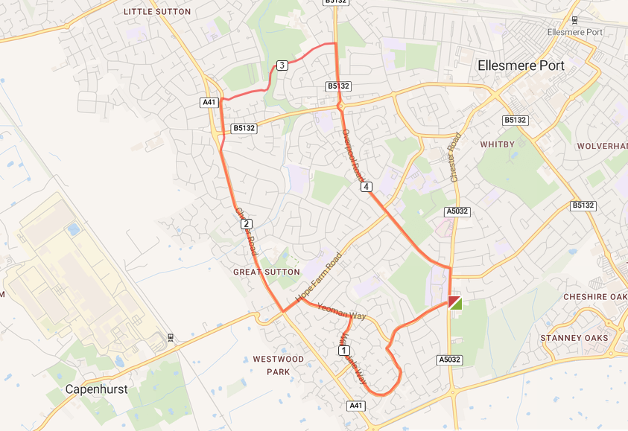

- Left out of the club and cross the road to Sycamore Drive
- Continue to Willowdale Way run the length of the road until you reach Yeoman Way
- Left on to Hope Farm Road and right at the lights on to the A41
- Right at Sutton Way and left on Old Chester Road until you reach Mill Lane
- Run up Mill Lane and right at the end of the road on to Overpool Road
- Run the length of the road and turn right at the end of the road and run back to the club

