
Rake Lane 5.1 mile

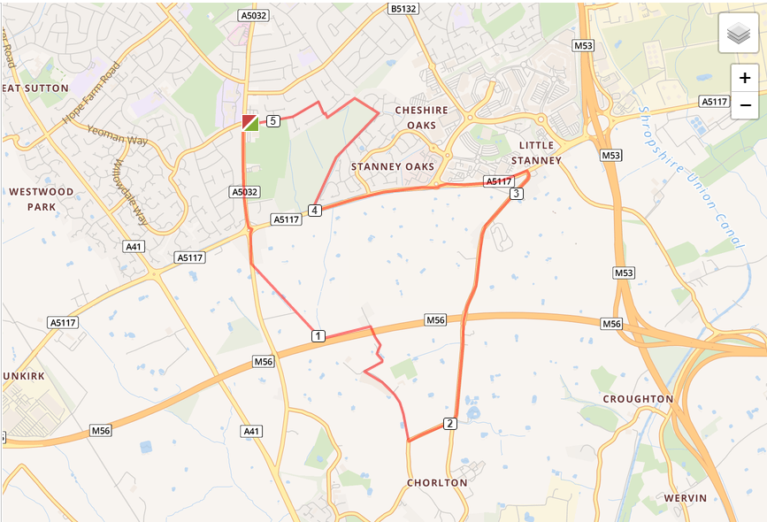

- Head out of the club and turn left, turning left again on Chester Road
- Cross over the Strawberry roundabout and run down the bridle path off the left, before the motorway bridge
- Turn right at end of bridle path and run until you reach Rake Lane
- Turn left and run the length of Rake Lane until you reach A5117
- Turn left and run down the Stanney Woods car park, turning right
- Turn right and run around the woods until you reach Woodland Road, exit by manhole cover
- Turn left on Woodsome Drive and run back to the club

